Tempus Resource

Quick Reference Guide

Planners – Project / Service Manager and Resource Manager
Phase 1 (Budget) - Knauf Configuration
Note: This document is confidential and intended for Knauf only. It is a quick reference, not a full training manual. Do not distribute, copy, forward, or disclose without the express consent of Valkeen GmbH.

Contents
This guide has two tables of contents:
- A static overview below for a one-glance map of all sections.
- A live Word table of contents on the next page with clickable links and page numbers. Right-click it in Word and choose Update Field (or press F9) the first time you open the document.

Static Section Map
# | Section | For
1 | Glossary & Quick Lookup | Both
2 | Sign-in and Homescreen | Both
3 | Find and Open a Project | Both
4 | Create a Project | PM/SM
5 | Project Master Data (Attributes) | PM/SM
6 | Project vs. Service | PM/SM
7 | Plan Resources (Allocations) | Both
8 | Plan Costs (Allocations € and Financials) | PM/SM
9 | Bulk Project Allocation Flatgrid | RM
10 | Reporting Basics | Both
11 | Workflows, Locks, and Saving | Both
12 | FAQ and Troubleshooting | Both

Live Table of Contents

Glossary & Quick Lookup
Both

Dense reference — deep product narration stays in the ProSymmetry Help Center.
Tempus distinguishes Projects versus Services using the Type attribute — it drives templates, roll-ups and reporting facets. Operational planning revolves around Mandays, with auxiliary Euro projections from the allocations grid (€ Cost) and non-labor lines in Financials. Phase 1 @ Knauf = Budget footprint — SAP actuals ingestion, forecasting cycles beyond budget and services-side resource granularity sit in Phase 2+. Every allocation edit generates resource requests for RM disposition.

Roles surfaced here
Badge | Typical Knauf persona | Responsibility
PM/SM | Project / Service managers | Steward master data, labor + non-labor plans for assigned work.
RM | Resource managers | Approves staffing changes, stewards pooled capacity tooling.
Both | Shared chapters | Navigation, locating projects, report consumption fundamentals.

IT Controlling, PPM and Admin-Light colleagues use separate curricula even when UI chrome looks similar — extra tiles are entitlement-driven.

Units & grains (cheat line)
Focus | Default @ Knauf
Mandays in Allocations | Month (switchable day→year)
Service portfolio views (RM tooling) | Usually month
Non-labor financial planning | Quarter (Month optional)
Roll-up dashboards downstream | Quarter / Year as agreed with Controlling

€ Cost tab = purely derived staffing euros. CAPEX/OPEX classifications belong to controlling policy — planners pick the descriptive category Finance defines.

Phase‑1 footprint (one glance)
Planning PM/SM: master data ✅, staffing plans ✅ (projects), staffing on services ⚠️ backlog per Knauf roadmap, staffing euro derived ✅, non-labor cost lines ✅, reporting consumption-only ✅, building brand-new pivot reports ⚠️ (PPM/controlling toolchain). Operational actuals bridging SAP ↔ Tempus ⚠️ later program wave.
Seven non-labor families you see in intake/financials training decks still apply verbatim: External consulting • IT licences • IT leasing • Managed IT • Other • CAPEX • Internal effort placeholders (rate × person-days from allocations downstream).

Where to steal better pictures
Screenshots bundled with Siemens/SHS PDFs (_tools/extract_pdf_images.py) or Help attachments (import_help_center_article_images.py + browser network export → --urls-file) land under sources/… first; after legal review rename into screens/, tag generic/customer in index.json, expose via lib:….
Note: Do not silently redistribute ProSymmetry IP — align with Knauf legal + vendor wording before circulating merged artwork.

Sign-in and Homescreen
Both

At a glance
• Open https://knaufdev.tempus-resource.com/ (sandbox) or your production URL in Chrome.
• Use SSO in production, or the local Log In for sandbox/training accounts.
• The homescreen tiles you see depend on your global role. PM/SM and RM see different sets.

Sign In
How to
1. Open the Tempus URL provided by Knauf IT.
2. Choose Continue With Saml (orange) for production SSO, or Log In (green) for sandbox/training accounts.
3. For sandbox: enter the user (for example pm for PM/SM, rm for RM) plus the Knauf-issued password.
4. Land on the Welcome screen with your name and the environment label (for example Knauf - DEV).

Warning: Never share passwords by email, chat, or in documents. Get sandbox credentials from the Knauf Tempus admin via the agreed secure channel.

Homescreen for PM/SM
The PM/SM profile stays intentionally lean: everyday work revolves around Project Management — the tiny + badge opens Create Project without an extra navigation hop — plus Report Management for dashboards your organisation shares. Environment text such as Knauf - DEV confirms you are on the correct tenant. The illustration below is a compact crop of the two-tile layout as seen with the PM/SM (Dummy) training login so you can visually match the labels on your own screen. 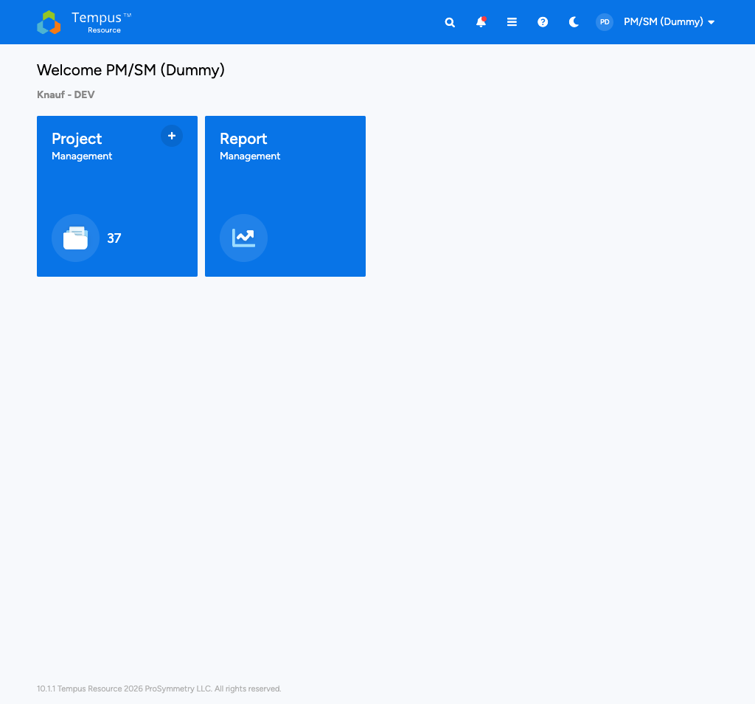

Homescreen for RM (Typical)
RM typically sees more cross-project tiles, for example Resource Management, Bulk Project Allocation Flatgrid, All Resource Requests / Resource Requests, and Bulk Resource Capacities. The exact set depends on Knauf's RM global role.
Note: If a screen mentioned in this guide is missing from your homescreen, you are most likely not granted that area. Ask the Knauf Tempus owner if access is intended.

Top Bar Reference
The blue top bar is identical on every screen. Each icon is a single click.
Icon | Name | What it does
Tempus logo | Home | Back to the homescreen.
 | Search | Global search across projects, resources, reports.
 | Notifications | In-app notifications. A red dot means unread items.
 | Menu | Full navigation drawer with every module you have access to.
 | Help | Opens the ProSymmetry Help Center in a new tab.
Moon / Sun | Theme | Toggle dark mode.
Your avatar | Profile | Profile, Subscriptions, Logout.

Notification Subscriptions
How to
1. Click your avatar > Subscriptions.
2. On the Project tab, add the projects you want to follow.
3. For each project, enable Attributes, Allocations, and Deleted notifications.
4. On the Resource Request tab, enable the outcomes you care about for requests you submit.

Tip: Avoid the "all projects" option. Each subscription has to be removed individually, so being selective saves time.

Find and Open a Project
Both

At a glance
• The Project Management tile lists every project you can see.
• Knauf project names follow a pipe-separated pattern, for example XU | GLO | P4K | Release 2026.1.
• Use Search (contains-match) to find a project by any name fragment.
• The blue P badge next to a project marks a Proposal (not yet approved).

Open Project Management
Opening the Project Management tile switches you into the consolidated project catalogue (default Grid tab). Along the toolbar you recognise Create Project, catalogue actions, global Search, quick filters and the Default view chip that opens the Tempus View Manager explained later in this chapter. Rows list every project whose security grants you visibility; compact blue p indicators still mark Proposal records. Below is an embedded excerpt of that grid — narrower than the full monitor capture so your eye stays with the explanatory text. 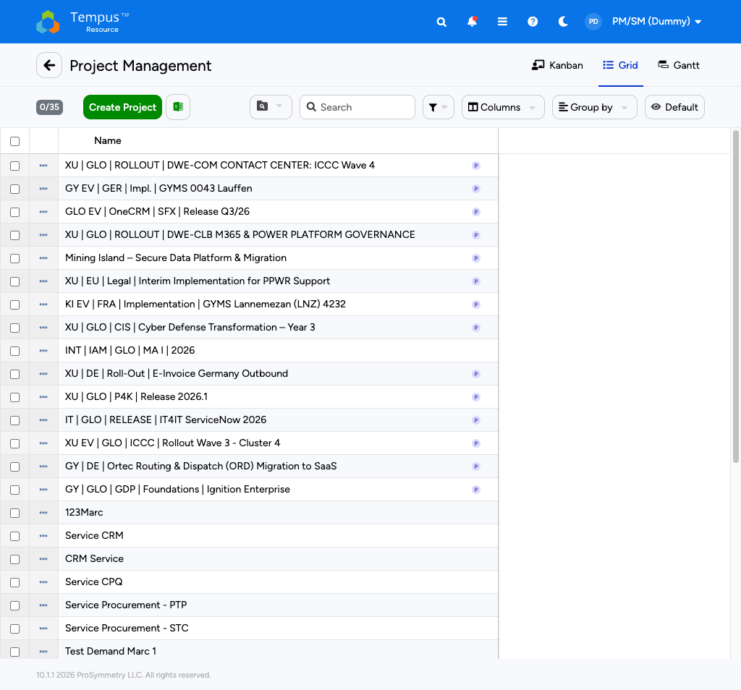

Tabs
Tab | Use it for
Kanban | Status-by-status visual board.
Grid | Tabular list with filters and grouping. Default for planners.
Gantt | Timeline view across projects.

Toolbar
Control | What it does
Create Project (green) | Start a new project (PM/SM with rights only).
Excel export | Export the current grid.
Search | Free-text search on names.
Filter | Quick filters (attribute-based).
Columns | Insert / hide grid columns.
Group by | Group rows by any attribute.
Default view | Switch between saved / public views.

How to
1. Open the Project Management tile.
2. Type a fragment of the project name into Search, for example P4K.
3. Click the project name to open it. The project opens in its Attributes view by default.
4. Switch to Allocations, Financials, etc. via the view selector on the top right.

Note: If you cannot find a project that should be there, the most likely reason is project-level security. PM/SM only sees projects where the security group grants access. Ask the project owner or the Tempus admin to add you.

Project-Detail View Selector
Inside an opened project, the dropdown next to the project name switches between the views. Typical views available to PM/SM:
View | Purpose
Attributes | Master data (intake form, PMO).
Allocations | Resource and labor cost planning.
Financials | Non-labor cost lines, planned vs. actual.
Build Team | Replace generic roles with named resources.
Audit Log | Project-specific change history.
Files | Attachments.

Managing Grid Views
Every grid (Project Management, Resource Management, Allocations, Financials, etc.) has its own list of views that you can save, share, and switch between. Open the view dropdown via the Default button on the top right of the toolbar.
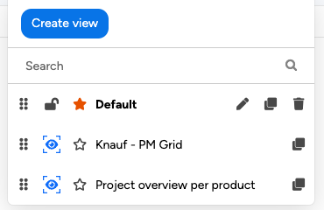
The View Manager dropdown. Top row shows your editable Default layout; public Knauf presets appear underneath with clone-only tooling.

Icon | Meaning
 | Drag handle - reorder views by drag-and-drop.
 | Lock a view in its current state. Locked views ignore any changes you make (filters, columns, etc.). Useful for reference views you do not want to disturb.
 | Default view - opens automatically when you enter the screen. Click an outline star on another view to make it your default.
 | Edit the view name. Provide a new name and confirm with the green checkmark.
 | Clone the view. Creates a copy you can freely edit (the safe way to use a public view).
 | Delete the view. Only your own private views can be deleted.
 | Public view - administratively shared. Cannot be edited or deleted, only cloned.

Tip: Public views (with the  eye) are managed centrally by Knauf's Tempus admins. Always clone them before changing anything - your edits stay in the cloned copy.

How to
1. Open any grid (for example Project Management).
2. Click the Default view button to open the dropdown shown above.
3. Click next to a public view if you want a personal copy.
4. Click into the new view, change filters / columns / grouping, and changes save automatically.
5. Optionally click to rename, to set as default, or  to freeze it.

Create a Project
PM/SM

At a glance
• PM/SM creates Regular Projects only. Services are created by RM / IT-Controlling per Knauf governance.
• A new project opens directly in the Attributes view with an intake form to fill in.
• Mandatory fields are marked with a red asterisk; you cannot save until they are set.
• The PMO section captures portfolio-level metadata (Above Red Line, Portfolio Status, WBS, etc.).

Start the Create Flow
How to
1. Open the Project Management tile or the + badge on the Project Management tile.
2. Click the green Create Project button.
3. Pick a template - PM/SM at Knauf sees a single option, Regular Project.
4. The new project opens immediately in its Attributes view.

When the wizard finishes scaffolding the record you immediately land in Attributes. The intake groups collect business metadata (portfolio, legal entity, product areas, timelines) ahead of allocations. Mandatory controls display a red asterisk; dropdowns tinted green echo Knauf’s recommended combinations straight from Phase 1 configuration. The stitched capture below concentrates on those controls so paragraph and screenshot read together like a textbook walkthrough rather than an isolated wallpaper. 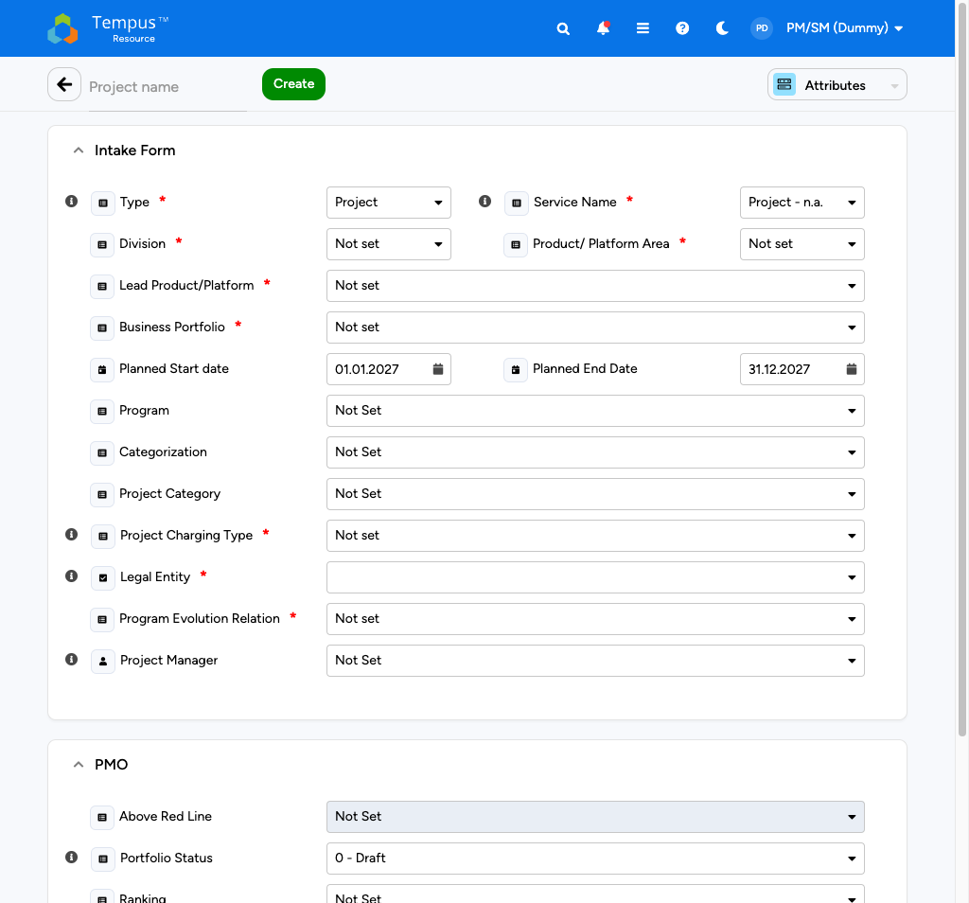

Intake Form - Mandatory Fields
Field | Example value | Notes
Type * | Project | Set by the template.
Service Name * | Project - n.a. | Stays at default for regular projects.
Division * | Enterprise Solutions | Drives portfolio roll-ups.
Product/Platform Area * | MSS | Sub-area.
Lead Product/Platform * | SFX Platform | Leading platform.
Business Portfolio * | MoB | Drives portfolio reporting.
Project Charging Type * | choose from list | Internal charging rule.
Legal Entity * | choose from list | Knauf legal entity.
Program Evolution Relation * | beneficial | Relation to the parent program.

Intake Form - Optional Fields
Field | Used for
Planned Start date / Planned End Date | Drives the Allocations and Financials timeframe.
Program | Parent program link.
Categorization | new, existing, extension.
Project Category | For example Maintenance.
Project Manager | The Tempus user owning the project.

PMO Section
After the intake block the dialog continues with the PMO panel (Above Red Line, Portfolio Status, external numbering, WBS). These fields roll straight into portfolio analytics, so completeness matters even though they feel administrative. Scroll until every red asterisk is satisfied before invoking Create; the illustrative crop focuses on PMO-only controls so planners know exactly where governance data lives relative to intake. 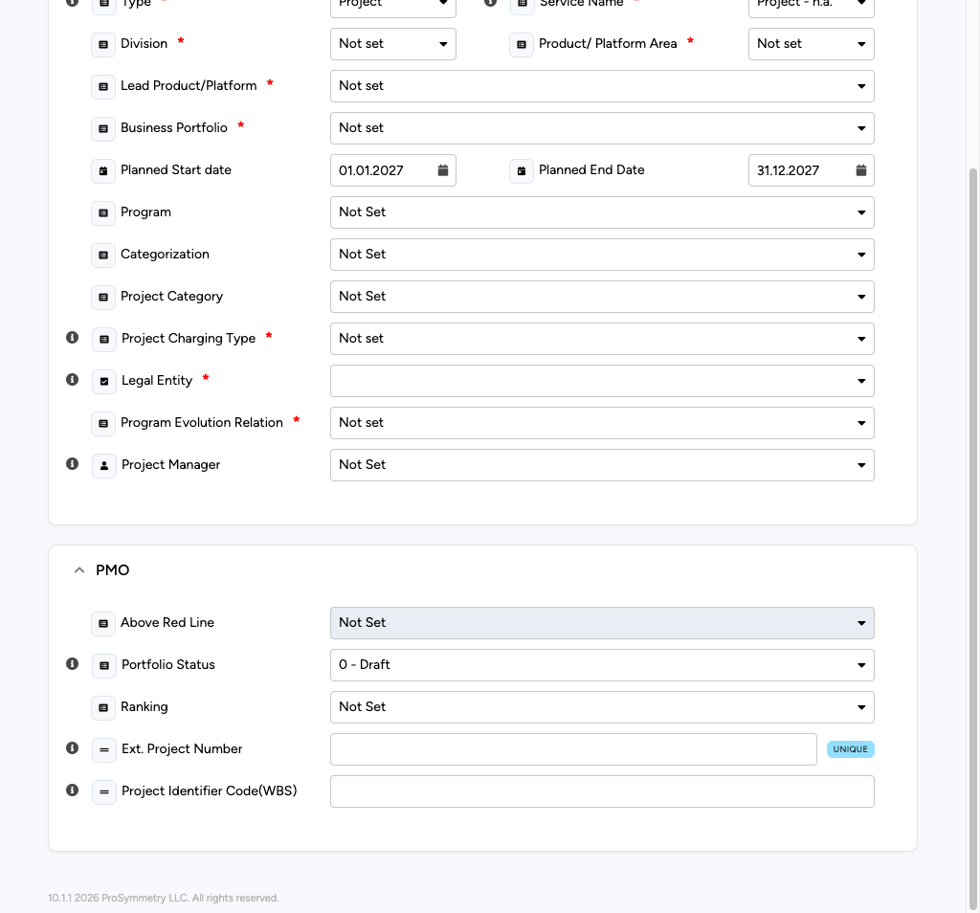
PMO Field | Notes
Above Red Line | Portfolio prioritisation flag.
Portfolio Status | Starts at 0 - Draft.
Ranking | Portfolio ranking.
Ext. Project Number | Tagged UNIQUE - no duplicates allowed.
Project Identifier Code (WBS) | Knauf WBS code, for example A.0248.10.000460.22.

Tip: Set Planned Start / End right away. Without them, the Allocations grid stays empty and the € Cost / Manday rows have nowhere to land.

Save
How to
1. Enter the Project name in the top-left field.
2. Fill in all mandatory fields (red asterisks).
3. Click Create (green button next to the project name).
4. Tempus persists the project and reopens it in the Attributes view, ready for further work.

Warning: If a mandatory field is missing or a duplicate Ext. Project Number is detected, the Create click fails silently. Scroll through the intake form and look for red borders or the duplicate tooltip on the Ext. Project Number field.

Project Master Data (Attributes)
PM/SM

At a glance
• The Attributes view holds all master data and is the first place to clean up after creating a project.
• The form is split into Intake Form and PMO sections. PM/SM does not see System Fields or Dependency Section.
• Edit directly in the view, click Save in the top-left. No separate checkout step for attributes.
• Green-highlighted dropdowns mark valid Knauf attribute combinations.

Stammdaten live here: dropdown-driven sections for portfolio alignment, timelines, classifications and PMO artefacts. Editing is immediate—there is no checkout ritual like in Allocations. Save frequently; each save stamps the CREATED / UPDATED badges embedded in each section heading. Rather than dumping a full-window wallpaper, we embed only the cropped centre of the Attributes layout so explanatory sentences and screenshot stay visually coupled. 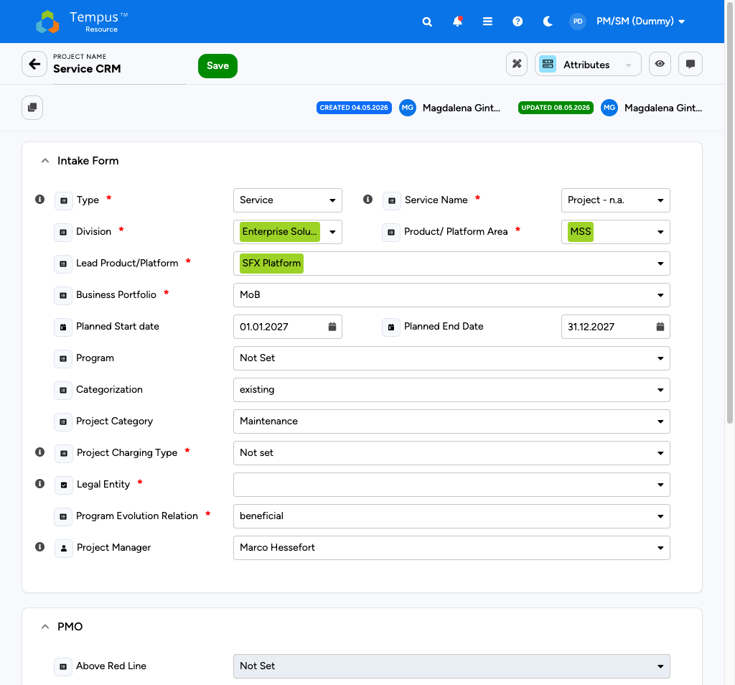

Editing Rules
Rule | Effect
Lock conflict | If another user has the project locked, your save is rejected. Wait for the lock to clear.
Audit trail | Every change writes to the Audit Log; the CREATED / UPDATED badges show who and when.
Cascade | Some attributes (Division, Business Portfolio) drive cost roll-ups; changes ripple into portfolio reports.
Green badge | Cosmetic Knauf hint that the value is a recommended pick for the current Division / Area combination.

What to Maintain Day-to-Day
When you... | Update this
Get a new project name from the business | Project name, Ext. Project Number, Project Identifier Code (WBS).
Get scope clarity | Categorization (new / existing / extension), Project Category.
Get scheduling | Planned Start / End Date.
Get the responsible PM | Project Manager.
Reach a portfolio milestone | Portfolio Status (e.g. 0 - Draft -> 1 - Approved).

What PM/SM Cannot See / Edit
Block | Who maintains it
System Fields (ID, Security Group, Assignment Workflow) | Admin Light / IT Controlling.
Dependency Section (predecessor / successor) | Admin Light / PPM.
Financial Categories master data | IT Controlling.
Resource Hierarchy | RM / Admin.

Note: A red asterisk on a field that you cannot edit usually means another role has to set it. Reach out via the agreed channel rather than trying to work around it.

Saving
How to
1. Make your edits in the dropdowns / text fields.
2. Click Save in the top-left (green button).
3. The CREATED / UPDATED badges at the top of the section refresh with your user.
4. Move on to Allocations or Financials via the view selector.

Tip: Use Search in the Project Management grid to find your project again, even after you renamed it - search is contains-based.

Project vs. Service
PM/SM

Type chooses the template family: Project for time-boxed delivery trains, Service for evergreen business capabilities. The UI shell is the same; variance is which attributes default, how roll-ups tag and which policies Controlling applies.
Phase 1 onboarding for PM/SM is about Regular Projects creation. Services are provisioned by RM / Controlling governance; you still maintain master data and Financials on services you steward, but deliberate Manday staffing for services is out of scope year one per Knauf steering — document demand elsewhere only if Controlling explicitly agrees to avoid shadow planning.
Practical tells: names like Service CRM flag service mode, while long XU | GLO | … prefixes usually mean project delivery. Toggle a Type column through Columns, then save a filtered view if you only want one family on screen.
Vendor-neutral explainers such as Project Management Grid Views and Resource Management Grid Views pair well with this Knauf-specific rule set when you need more screenshot-led storytelling.
Note: Escalate roadmap pressure for service-side labor planning through IT Controlling — do not fork parallel Excel capacity models.

Plan Resources (Allocations)
PM/SM | RM

At a glance
• The Allocations view of a project is the home for resource planning. PM/SM works here for their own projects; RM uses it when supporting a specific project.
• Standard unit at Knauf is Manday; switch to € Cost for a live euro view.
• Default grain is Month. You can change to Day, Week, Quarter, or Year.
• Editing requires Checkout first. Save with Check In; release without saving with Release.

Open the Grid
From within an opened project, switch the view selector to Allocations. The grid honours the project's planned horizon, groups demand rows, and honours the Checkout workflow described later in this booklet. Monthly Manday granularity remains the Phase 1 default; heatmaps tint once data exists. Rather than occupying the entire page height, we inline a tightened crop centred on planning cells so narration and visual reinforce each SHS-style explanation beat. 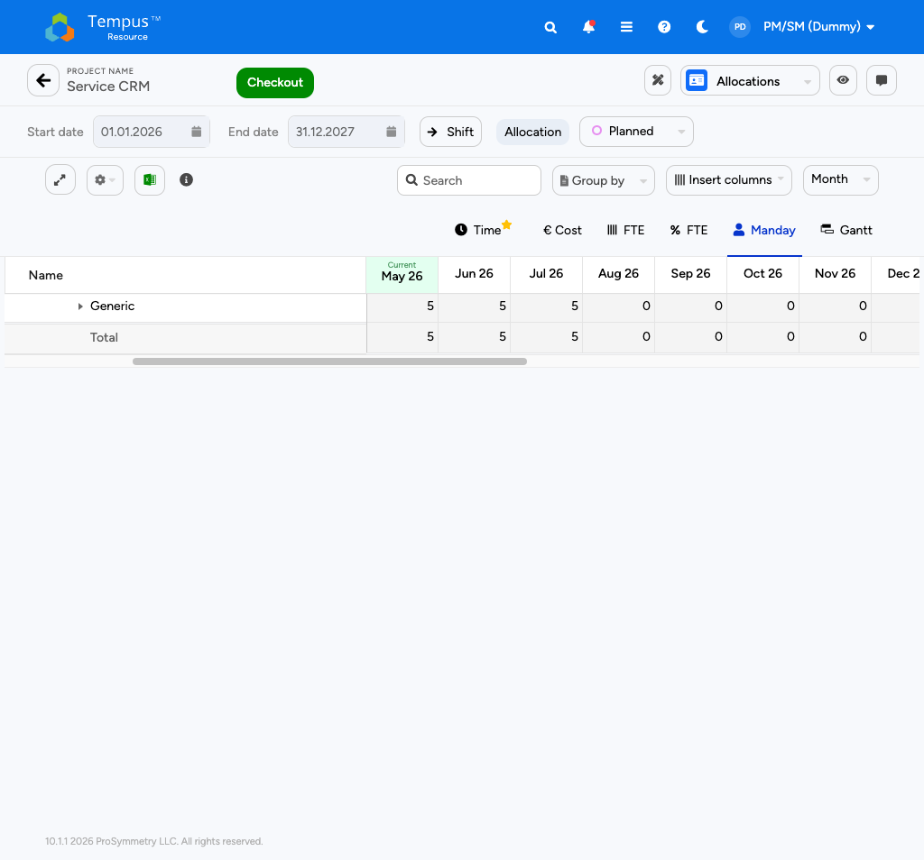

Toolbar Reference
Control | Purpose
Checkout (green) | Acquire the edit lock.
Start / End date | Restrict the visible window.
Shift | Bulk-shift assignments by N months.
Allocation / Assignment toggle | Switch between project-level and assignment-level edits.
Planned / Actual | Switch the editable series.
Expand all | Open all groups.
Options (gear) | Heatmaps, totals, filters.
Excel export | Export the current grid.
Group by | Group rows by attribute.
Insert columns | Add resource / project / assignment attributes as columns.
Grain selector | Day / Week / Month (default) / Quarter / Year.
Unit tabs | Time, € Cost, FTE, FTE %, Manday (default), Gantt.

Add a Resource
How to
1. Click Checkout to acquire the lock.
2. In the empty row at the bottom of the grid, start typing the resource role (for example *Business Analyst).
3. Pick the role from the dropdown - a new row appears.
4. Enter planned Mandays per month in each cell. Drag, copy-paste, or use the keyboard to fill ranges.
5. Click Save and Check In at the top to persist; this also creates the resource request for RM approval.

Tip: The * prefix marks demand-planning (generic) roles. Use them in early planning; let RM replace them with named resources via the Build Team view as the project firms up.

Switch to € Cost
Click the € Cost tab to see the same allocation expressed in euro. Figures stay derived—you never type currency directly—and update when Mandays or rate tables shift. Keeping the excerpt narrow preserves the handbook feeling: text calls out behaviours, screenshot proves the visuals. 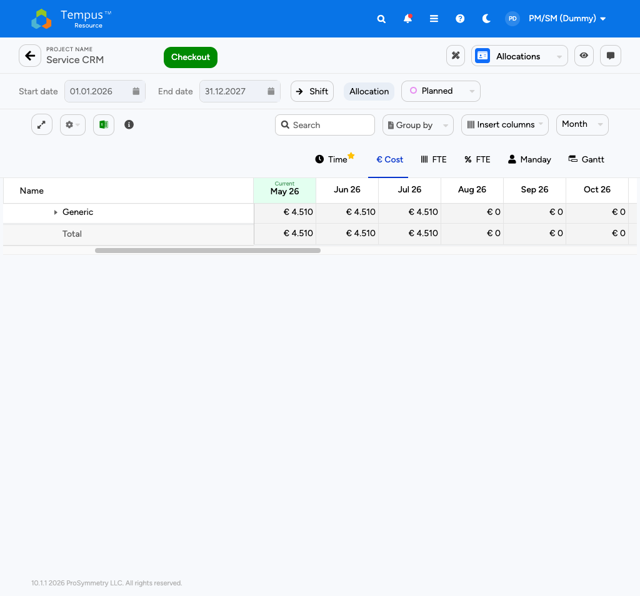

Save vs. Release
Button | When to use
Save and Check In | Keep the edits and release the lock. Creates / updates resource requests.
Release | Discard the edits and release the lock. Use when you experimented or made mistakes.
Save (without Check In) | Keep the lock for further editing while persisting the current state.

Resource Request Lifecycle
Whenever you save an allocation change, Tempus creates a resource request. The dot next to the resource shows the status:
Status | Meaning
Pending (pink) | Awaiting RM decision.
Approved (green) | RM accepted - capacity is firm.
Replaced (blue) | RM swapped the demand role for a named resource.
Rejected (red) | Revise and re-submit, or escalate.

Note: Knauf's standard Knauf time grain on Allocations is monthly. Quarterly grain is mostly used for portfolio rollups in reports, not for daily planning.

Plan Costs (Labor and Non-Labor)
PM/SM

At a glance
• Labor cost is derived: switch the Allocations grid to € Cost to see it.
• Non-labor cost lives in the Financials view: external consulting, licenses, leasing, managed services, other, CAPEX.
• The Financials grid lets you toggle Include labor costs to see one combined picture.
• Default grain in Financials at Knauf is Quarter; you can switch to Year or Month.

Labor Cost: From Allocations
The € Cost tab in the Allocations grid is read-only - it derives from your Mandays and the resource's daily rate. Embedded below at reduced width is the euro perspective on the Service CRM example so you recognise column bands without scrolling away from guidance. 
Tip: To change a labor cost, change the allocation (Manday tab). The € figure updates immediately. Rates are owned by IT Controlling and updated centrally.

Non-Labor Cost: Financials View
Switch the view selector to Financials to orchestrate leases, licences, managed services and other non-labour postings. Rows respect the project's quarter granularity by default yet remain drillable monthly when needed. Compact illustration: 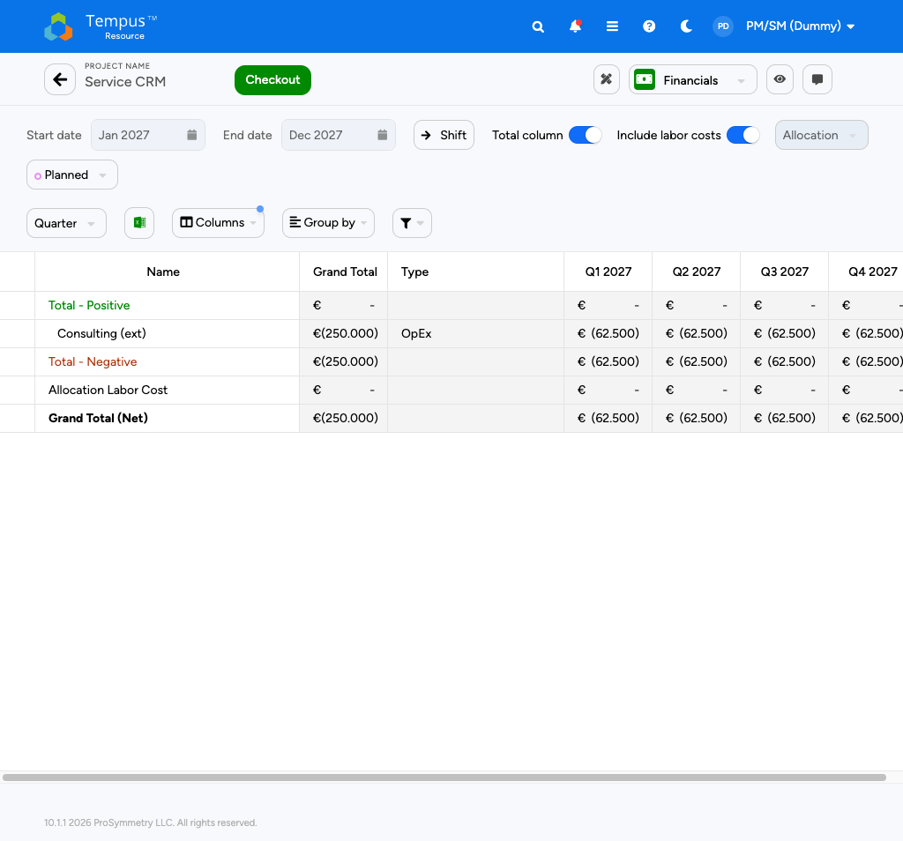

Toolbar Reference
Control | Purpose
Start / End date | Window of the financial grid.
Shift | Bulk-shift lines by months.
Total column toggle | Add or remove the grand total column.
Include labor costs toggle | Pull labor cost into the same view.
Series (Planned / Actual) | Which series is editable.
Quarter dropdown | Time grain.
Excel | Export.
Columns / Group by / Filter | Grid customisation.

Columns You Will See
Column | Use
Name | Cost line name (free text).
Grand Total | Sum across the timeframe.
Code | Optional internal code.
Description | Free text.
Type | OpEx or CapEx.
Time columns | Quarterly / yearly buckets, editable in Planned mode.

Roll-Up Rows
Row | Meaning
Total - Positive (green) | Revenue or positive entries. Rare for Knauf IT projects.
Total - Negative (brown) | Sum of all cost lines.
Allocation Labor Cost | Pulled from Allocations when Include labor costs is ON.
Grand Total (Net) (bold) | Net result for the timeframe.

Add a Cost Line
How to
1. Switch to the Financials view (the lock is shared with Allocations).
2. Click Checkout if you have not done so already (in the Allocations view).
3. Click the action to add a new line, then fill Name, Description, Type (OpEx / CapEx), and the cost value in the right time bucket.
4. Save the project (Check In). The line shows in the totals and feeds portfolio rollups.

Warning: Cost values entered as positive numbers are typically displayed in parentheses €(...) because Tempus shows costs as a negative net effect. Stick to entering positive amounts in the cost lines and let Tempus take care of the sign.

Seven Cost Categories - Reminder
When adding a non-labor line, pick a name that maps to one of:
- External consulting
- IT licenses
- IT leasing
- Managed IT services
- Other costs
- CAPEX
- Internal effort (this one is implicit via Allocation Labor Cost)
Note: The exact wording and codes are defined by IT Controlling. Stick to the agreed list so portfolio reports stay clean.

Bulk Project Allocation Flatgrid
RM

At a glance
• RM-only screen in the Knauf role model. PM/SM does not see the BPA Flatgrid tile.
• The Flatgrid lets you edit allocations across many projects and resources in one grid.
• Three filter modes drive what is loaded: by Project, by Resource, or Default.
• Saving works the same way as in single-project Allocations: each change creates resource requests.

The Bulk Project Allocation (BPA) Flatgrid is an RM-heavy cockpit; planners rarely open it themselves. For awareness, note the sprawling matrix and shared toolbar DNA with single-project grids. The illustrative crop below was taken with sandbox elevation so you can recognise the UX if an RM walks you through a remediation session. 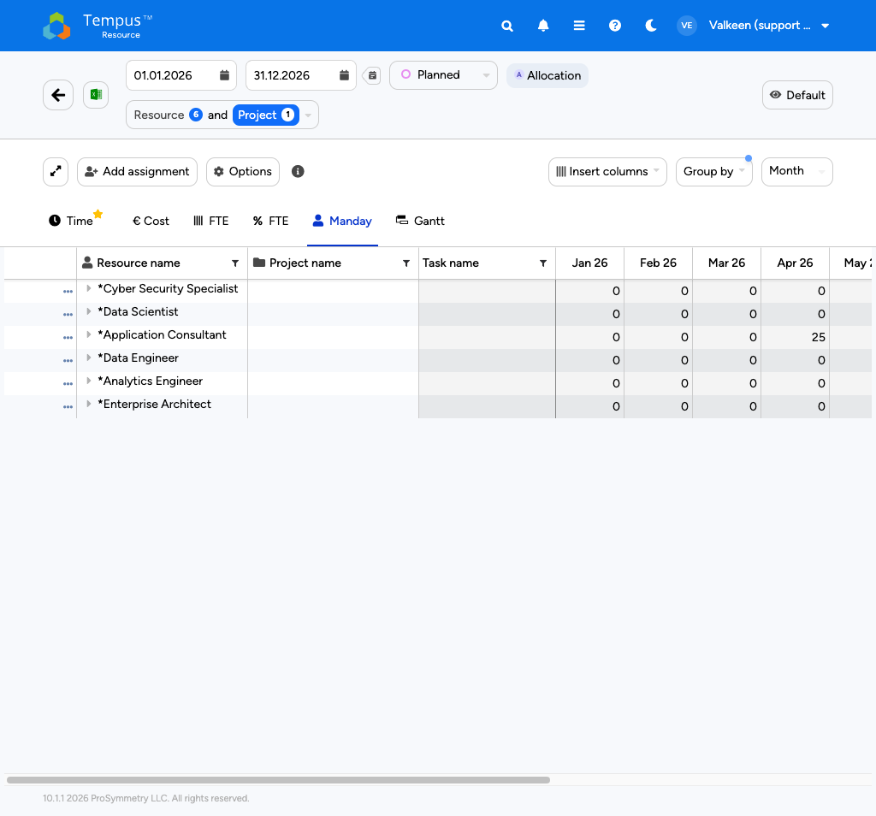
Note: The screenshot above was captured in the sandbox with an admin-style profile so the full toolbar is visible. The day-to-day RM profile sees the same grid and toolbar.

Filter Modes
Mode | Behaviour | Use when
Project | Pick projects -> their resources are auto-loaded. | You manage a portfolio and want resource demand per project.
Resource | Pick resources -> their projects are auto-loaded. | You manage people and want every project they touch.
Default | Free choice on both sides; lets you add new allocations to resources not yet on a project. | Initial setup or modelling.

Toolbar Highlights
Control | What it does
Expand grid | One-click full expansion.
Add assignment | Create a Resource-Project-Task combination on the fly.
Options | Heatmaps, totals, filter by request status.
Insert columns / Group by | Customise what you see.
Time granularity | Day / Week / Month / Quarter / Year.
Unit tabs | Manday (typical), € Cost, FTE, FTE %, Time, Gantt.
View management | Save / clone / lock / set default / delete personal views.

Working Pattern for RM
How to
1. Switch the mode selector to Resource and pick the resources you cover.
2. Confirm the timeframe matches the cycle you are working in (typically the budget year).
3. Insert columns: Project name, Business Portfolio, Type, Project Manager.
4. Group by Project name for a per-project view, or by Resource for a per-person view.
5. Save a personal view if you find yourself recreating the same setup.

Add a New Assignment
How to
1. Click Add assignment.
2. Pick a project, a resource, and a task.
3. Tick Allow new Resources if the resource is not yet on the project, or Add new Task to introduce a task on the fly.
4. Click Add new assignment. A row appears with editable cells.
5. Type the allocations per period and Save.

Reviewing Pending Resource Requests
How to
1. Open Options in the toolbar.
2. Open Filter by Resource Request Status and tick Pending.
3. The grid filters down to assignments waiting for your action.
4. Approve / replace / reject row by row, then Save.

Tip: Public views are read-only. Clone the public view first if you want to tweak filters or columns and keep them across sessions.

Reporting Basics
Both

At a glance
• Reports live in the Report Management tile.
• Planners typically consume reports built by Controlling / PPM rather than build new ones.
• PM/SM at Knauf does not see the "create new report" tiles, only the Report list.
• Reports tagged LIVE DATA (green badge) refresh automatically every time you open them.

What PM/SM Sees
A focused report list with the Knauf-managed reports. No tiles to create new reports—layout authoring is reserved for elevated roles. The slender capture shows how Planner accounts simply pick a workbook and open. 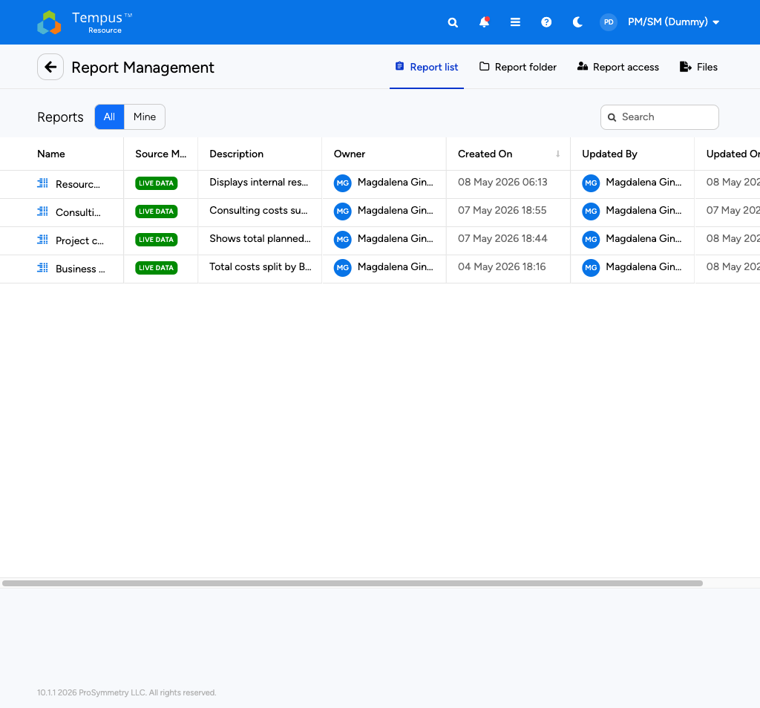

Report Columns
Column | Use
Name | Click to open the report.
Source Mode | LIVE DATA means refreshed on every open.
Description | Short summary maintained by the owner.
Owner / Updated By | The Knauf colleague responsible.
Created On / Updated On | Dates.

Recurring Knauf Reports Worth Knowing
Report | What it shows
Resource planning per product/platform | Capacity vs. demand by product area.
Consulting Costs Summary | External consulting per project / division.
Project Cost | Total planned cost across the portfolio.
Business Portfolio total IT cost | Portfolio-level cost rollup.
Timesheet Status / Audit | Operational compliance views (Phase 2).
Skill Matrix Report | Capability overview across the resource pool.

Note: Exact report names and contents depend on what your Knauf admin has shared with your role. If a report you need is missing, ask the owner (visible in the Owner column) to grant access.

Tabs
Tab | Purpose
Report list | The default list of reports you can access.
Report folder | Folder structure used by Controlling / PPM.
Report access | Manage visibility (owners only).
Files | File attachments linked to reports.

Opening and Filtering a Report
How to
1. Click the report name from the Report list.
2. Use the filters at the top of the report to narrow the scope (date range, division, portfolio).
3. Use the export action to download Excel / CSV / PDF if you need an offline copy.
4. For repeated use, ask the owner to add you to the report's scheduled delivery (where available).

Tip: Build a personal homescreen workflow by subscribing to the few reports you check daily, rather than reopening Report Management every time.

Workflows, Locks, and Saving
Both

Attributes save immediately via the green Save — no checkout dance. Allocations, Financials and Build Team behave like multi-user editors: Tempus issues a checkout lock before you may alter cells, and you close the session with Save and Check In (persist + broadcast to reporting) or Release (discard local scratch). While you hold the lock, colleagues see the red  affordance and cannot check out — coordinate or ask Admin-Light for an emergency unlock if someone ghosts the session.
Whenever Manday plans change, RM receives resource requests. Think of them as workflow envelopes: Approved freezes capacity, Replaced swaps a generic *Role for a named colleague, Rejected rolls edits back and paints the status chip red in the grid legend.
View | Lock? | Persist path
Attributes | No | Save (top-left).
Allocations / Financials / Build Team | Yes  | Checkout → edit → Save and Check In / Release.
Reports (planner profile) | — | Filter chrome is personal; does not publish.

Concurrent edit triage in one breath: greyed Save ⇒ you forgot Checkout; greyed Checkout ⇒ someone else (or you in another tab) still owns the database row; numbers missing in portfolio reports ⇒ you only staged work — run Save and Check In; odd audit entries after collaboration ⇒ compare notes, seldom a product bug.
Warning: Closing the browser mid-checkout does not auto-release — reopen the same project and finish with Save and Check In or Release.

Resource request choreography (mental model): PM/SM edits grid → request Pending → RM Approves / Replaces / Rejects → row colour + RM comments visible to PM/SM. Keep an eye on in-app notifications + subscription settings from the homescreen chapter.
Naming discipline still pays dividends: Division | Region | Tower | Theme for projects, Service <Capability> for ops services, unique Ext. Project Numbers, WBS strings like A.0248.10.000460.<id>. Reports and quick filters inherit those tokens verbatim.
Tip: For lock icon semantics straight from the vendor, cross-read the Help Center community note Locking Your View alongside this chapter — the iconography is intentionally shared between view management and project checkout.

FAQ and Troubleshooting
Both

Most anomalies are permissions or locking — review the project Audit Log before escalating.

Homescreen shows only two tiles
Expected PM/SM layout: Project Management and Report Management. More tiles imply a different role or extra entitlements via Knauf admin.

Create Project is missing
Role without Create entitlement or missing tile assignment. PM/SM with support approval → have admin verify; RM typically does not see it.

Project list visible, detail will not open / read-only
Seeing a project is not the same as editing: global role and project security group must align — involve the owner.

Allocations looks empty
Set Planned Start/End in Attributes and pull the grid time slider back to the project window.

Euro column stays at 0
Toggle month vs. quarter; if it persists, the resource has no day rate — IT Controlling / RM backfill.

Save stays inactive
Click Checkout first.

Someone else holds checkout
Coordinate or wait for release; Admin-Light can clear stuck locks.

Report ignores my numbers for hours
Pivots read checked-in data — without Save and Check In, figures stay stale.

Bracket amount €(...) instead of a positive sign
Display convention: spend reads negative vs. forecast — value is consistent.

Grain questions
See Glossary (“Units & grains”) — no duplicate table here.

Green dropdown with no error message
Knauf Preferred Value hint, not a hard block.
The short legend below covers every :icon token in this edition so mobile readers skip long hover experiments.
Icon | Where | Meaning
 | Top bar | Global search.
 | Top bar | In-app notifications.
 | Top bar | Module navigator.
 | Top bar | Help Center deep link.
 | View Manager | Drag to reorder.
 | Views / project | Locks layout or signals checkout.
 | Views | Active default view.
 | Views | Promote to favorite default.
 | Various | Rename / meta edit.
 | Views / rows | Safe copy instead of editing public views in place.
 | Private views | Delete only your own layouts.
 | Views | Admin-shared template — duplicate first.

Help and escalation (compact)
Topic | Contact
Accounts / access | Knauf Tempus admin
Rates and categories | IT Controlling
Resource requests / pool | Responsible RM pair
New dashboard projects | PPM / Controlling
Product / platform | Valkeen support per SLA

Note: Improvements to this companion document should still flow through the Knauf ↔ Valkeen steering forum — content changes are prioritised back into the Markdown repository.

